ECA5610 –ADVANCED WIRELESS COMMUNICATION SYSTEMS / 5G / 6G COMMUNICATION SYSTEMS

LAB REPORT
BY
STUDENT NAME: ROHIT KUMAR S
REGISTER NUMBER: 192312214
Git Hub Link: https://github.com/ROHITKUMAR013/ECA-5610---5G-6G-COMMUNICATION-

LIST OF EXPERIMENTS – ECA5610
Exp. No | Date | Experiment | Page no
1 |  | Simulation of FDMA in MATLAB
2 |  | Implementing TDMA Slot Allocation in GSM
3 |  | Spectrum Analysis of Sub-1 GHz, Mid-band & mmWave by plotting propagation loss
4 |  | OFDMA Resource Block Allocation
5 |  | MIMO System Simulation with BER Analysis
6 |  | 5G NR Frame Structure Analysis with Different Subcarrier Spacing
7 |  | Analog Beamforming
8 |  | Steering Angle Variation in MIMO Beamforming
9 |  | Massive MIMO Capacity vs SNR and Gain
10 |  | 5G Network Slicing Environment
11 |  | Implementation of IoT-based Smart Agriculture using MATLAB
12 |  | NB-IoT vs LTE-M Throughput Simulation
13 |  | V2X Latency Comparison
14 |  | 5G Throughput vs SNR with Modulation Labels
15 |  | AI-based Traffic Prediction for 5G Networks

Ex. No:1: Simulation of FDMA in MATLAB
Objective 1: To simulate an FDMA system by allocating individual frequency channels to multiple users and determine the channel bandwidth assigned to each user.

Program
clc; clear; close all;
fs=1000; t=0:1/fs:1;
TBW=600; Users=3;
CBW=TBW/Users;
fc=[100 300 500];
m=sin(2*pi*10*t);
s1=m.*cos(2*pi*fc(1)*t);
s2=m.*cos(2*pi*fc(2)*t);
s3=m.*cos(2*pi*fc(3)*t);
subplot(2,1,1)
plot(t,s1,'r',t,s2,'g',t,s3,'b'),grid on
title('192312214 FDMA Channel Allocation'),xlabel('Time(s)'),ylabel('Amplitude')
subplot(2,1,2)
bar(1:Users,CBW*ones(1,Users)),grid on
xlabel('Users'),ylabel('Channel Bandwidth (kHz)'),title('Channel Bandwidth User')

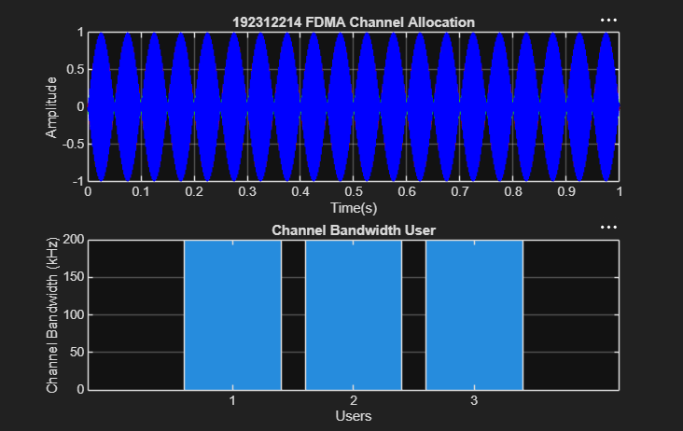

Objective 2: To calculate the data rate achieved by each user in the FDMA system based on the allocated channel bandwidth
Program
clc; clear; close all;
BW = 200; % Channel Bandwidth (kHz)
Users = 3;
M = 2; % BPSK Modulation
DataRate = BW*log2(M); % Data Rate (kbps)
Rate = DataRate*ones(1,Users);
disp(' User Data Rate (kbps)')
disp([(1:Users)' Rate'])
figure
bar(1:Users,Rate)
xlabel('Users')
ylabel('Data Rate (kbps)')
title(' 1922312214 FDMA Data Rate for Each User')
grid on

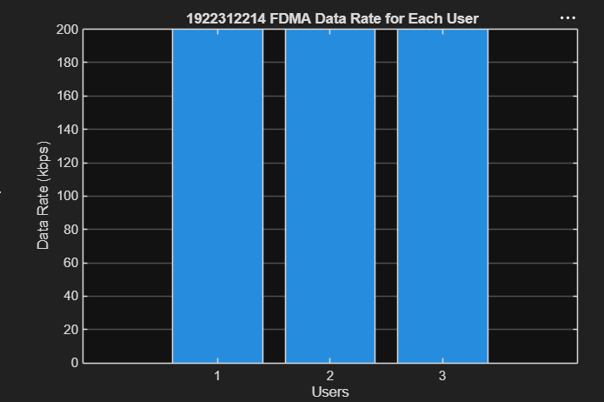

Objective 3: To evaluate the communication quality of the FDMA system by calculating the Signal-to Noise Ratio (SNR) for different users
clc; clear; close all;
Ps = 1; % Signal Power (W)
Pn = [0.1 0.05 0.01]; % Noise Power (W)
Users = 1:3;
SNR = 10*log10(Ps./Pn); % SNR in dB
disp('User Noise Power(W) SNR(dB)')
disp([Users' Pn' SNR'])
figure
bar(Users,SNR)
xlabel('Users')
ylabel('SNR (dB)')
title('192312214 Signal-to-Noise Ratio of FDMA Users')
grid on
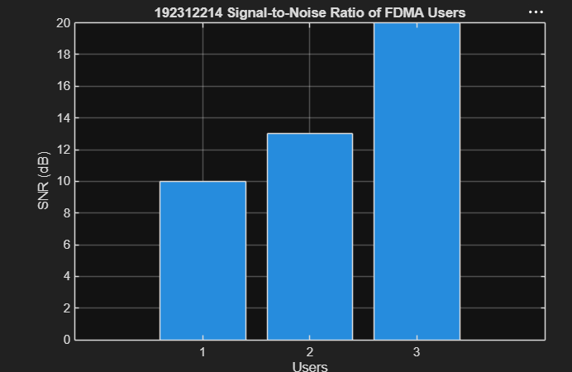
EXP 2: Implementing TDMA Slot Allocation in GSM.

Objective 1: Matlab Code and Output
Program
clc; clear; close all;
FrameTime = 4.615; Slots = 8;
SlotDuration = FrameTime/Slots;
t = 0:SlotDuration:FrameTime;
figure
subplot(2,1,1)
stem(t,ones(size(t)),'filled')
title('192312214 TDMA Time Slot Structure')
xlabel('Time (ms)')
ylabel('Slot Level')
grid on
subplot(2,1,2)
plot(t,ones(size(t)),'-o','LineWidth',1.5)
title('192312214 Continuous View of Slot Allocation')
xlabel('Time (ms)')
ylabel('Slot Presence')
grid on
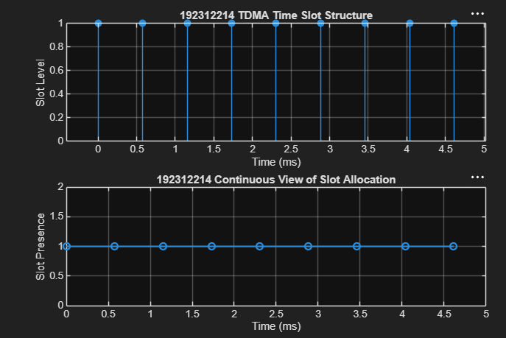
Objective 2: Matlab Code and Output
Program clc; clear; close all;
TotalSlots = 8;
AllocatedSlots = 6;
FreeSlots = TotalSlots - AllocatedSlots;
Utilization = (AllocatedSlots/TotalSlots)*100;
disp('Frame Utilization (%)')
disp(Utilization)
figure
% Graph 1: Simple Line Plot (SAFE - no bar function)
subplot(2,1,1)
plot([1 2],[AllocatedSlots FreeSlots],'-o','LineWidth',2)
title('192312214 GSM Frame Utilization (Allocated vs Free)')
xlabel('Slot Type Index (1=Allocated, 2=Free)')
ylabel('Number of Slots')
grid on
% Graph 2: Pie Chart (SAFE)
subplot(2,1,2)
pie([AllocatedSlots FreeSlots])
title('192312214 Slot Distribution in GSM Frame')
legend('Allocated','Free')
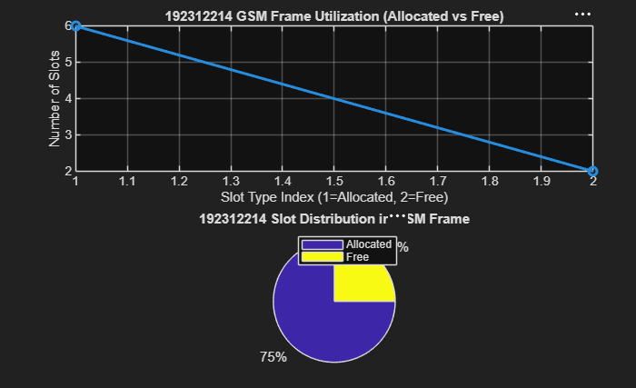
Objective 3: Matlab Code and Output

Program
clc; clear; close all;
Users = 1:8; % Total users
TotalSlots = 5; % Available slots
Alloc = zeros(1,8); % Initialize allocation
Alloc(1:TotalSlots) = 1; % Assign slots to first users
Blocked = 1 - Alloc; % Remaining users blocked
disp('User Wise Slot Allocation (1=Allocated, 0=Blocked)')
% FIXED: Closed the disp() function properly and simplified the variablename
disp(table(Users', Alloc', 'VariableNames', {'User', 'Status'})) % FIXED: Placed on its own line
% Graph 1: Allocation per user
subplot(2,1,1)
stem(Users, Alloc, 'filled', 'LineWidth', 2)
title('192312214 TDMA Slot Allocation per User')
xlabel('User Index')
ylabel('Slot Status (1=Allocated, 0=Blocked)')
ylim([-0.2 1.2])
grid on
output
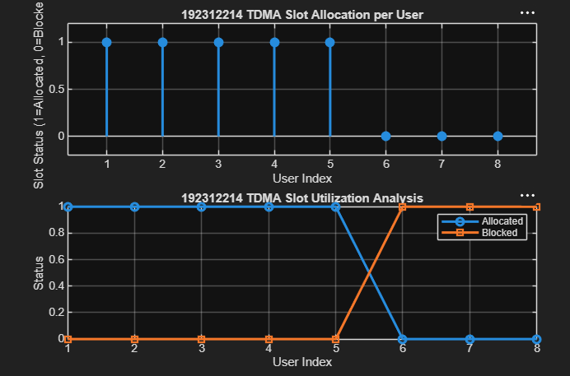
EXP 3: Spectrum Analysis of Sub-1 GHz, Midband & mm Wave by Plotting Propagation Loss.

Objective 1: Matlab Code and Output:
Program
clc; clear; close all;
d = 0.1:0.1:5; % Distance (km)
f = [900 3500 28000]; % Frequency (MHz)
PL1 = 32.44 + 20*log10(f(1)) + 20*log10(d);
PL2 = 32.44 + 20*log10(f(2)) + 20*log10(d);
PL3 = 32.44 + 20*log10(f(3)) + 20*log10(d);
figure
subplot(2,1,1)
plot(d,PL1,'b','LineWidth',2); hold on
plot(d,PL2,'r','LineWidth',2)
plot(d,PL3,'k','LineWidth',2)
title('192312214Propagation Loss vs Distance')
xlabel('Distance (km)')
ylabel('Loss (dB)')
grid on
subplot(2,1,2)
Freq = [900 3500 28000];
Loss = [PL1(10) PL2(10) PL3(10)];
plot(Freq,Loss,'-o','LineWidth',2)
title('192312214 Propagation Loss vs Frequency')
xlabel('Frequency (MHz)')
ylabel('Loss (dB)')
grid on
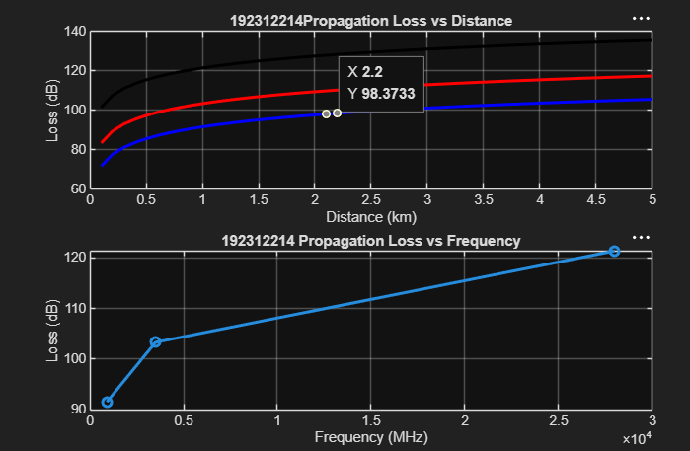

Objective 2: Matlab Code and Output:
Program
clc; clear; close all;
d = 2; % fixed distance (km)
f = [900 3500 28000]; % MHz
PL = 32.44 + 20*log10(f) + 20*log10(d);
figure
% -------- Graph 1: Frequency vs Loss --------
subplot(2,1,1)
plot(f,PL,'-o','LineWidth',2)
title('192312214 Propagation Loss vs Operating Frequency')
xlabel('Frequency (MHz)')
ylabel('Propagation Loss (dB)')
grid on
% -------- Graph 2: Band Comparison --------
subplot(2,1,2)
bar(PL)
title('192312214 Comparison of Propagation Loss Across Bands')
xlabel('Frequency Bands (Index: 1=Sub-1GHz, 2=Mid-band, 3=mmWave)')
ylabel('Propagation Loss (dB)')
xticklabels({'Sub-1GHz','Mid-band','mmWave'})
grid on

output
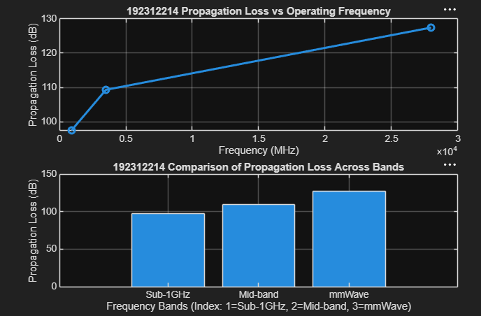
Objective 3: Matlab Code and Output:
Program
clc; clear; close all;
% Frequency bands (MHz)
f = [900 3500 28000];
% Distance (km)
d = 2;
% Propagation Loss (FSPL)
PL = 32.44 + 20*log10(f) + 20*log10(d);
figure
% -------- Graph 1: Simple Line Plot (SAFE) --------
subplot(2,1,1)
plot(f, PL, '-o', 'LineWidth', 2)
title('192312214 Propagation Loss vs Operating Frequency')
xlabel('Frequency (MHz)')
ylabel('Propagation Loss (dB)')
grid on
% -------- Graph 2: Safe Comparison Plot --------
subplot(2,1,2)
plot(1:3, PL, '-s', 'LineWidth', 2)
title('192312214 Band-wise Propagation Loss Comparison')
xlabel('Band Index (1=Sub1GHz, 2=Mid-band, 3=mmWave)')
ylabel('Propagation Loss (dB)')
grid on

output

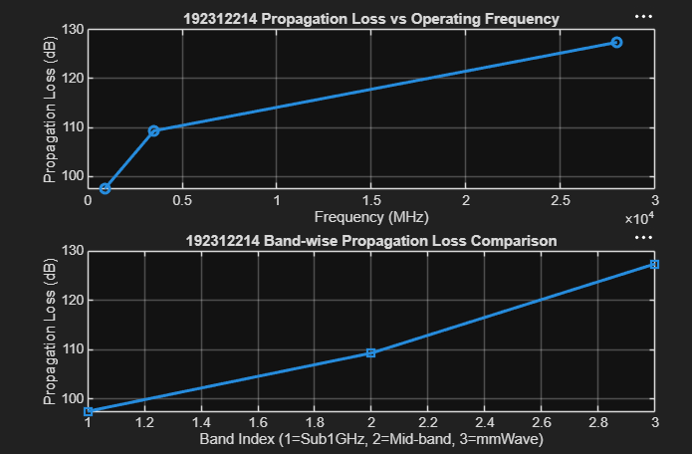

EXP 4: OFDMA Resource Block Allocation
Program
clc; clear; close all;
% System parameters
bandwidth = 10e6; % 10 MHz
rb_size = 180e3; % 180 kHz per RB
% Total Resource Blocks
total_RB = floor(bandwidth / rb_size);
% Users
users = 1:6;
% RB allocation (simple equal + remainder distribution)
base = floor(total_RB / length(users));
alloc = base * ones(1, length(users));
% FIXED: Moved the +1 to the same line, and moved utilization to a new linealloc(1:mod(total_RB, length(users))) = alloc(1:mod(total_RB,length(users))) + 1;
utilization = (alloc / total_RB) * 100;
disp('Total Resource Blocks:')
disp(total_RB)
disp('RB Allocation per User:')
disp(alloc)
figure;
subplot(2,1,1)
stem(users, alloc, 'filled', 'LineWidth', 2)
title('192312214 OFDMA Resource Block Allocation per User')
xlabel('User Index')
ylabel('Number of Resource Blocks')
grid on
subplot(2,1,2)
plot(users, utilization, '-o', 'LineWidth', 2)
title('192312214 OFDMA Resource Block Utilization (%)')
xlabel('User Index')
ylabel('Utilization (%)')
grid on
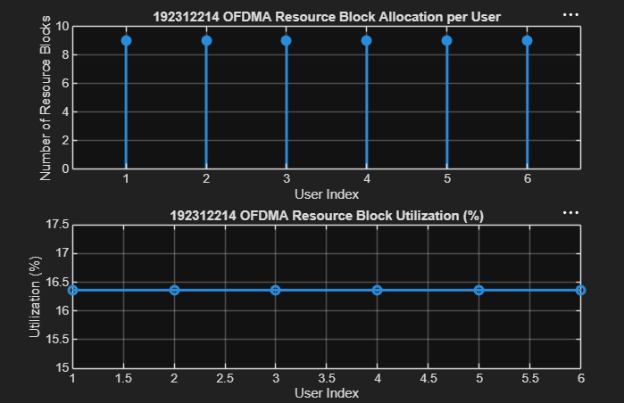

Objective 2 Matlab Code and Output:
Program
clc; clear; close all;
% Total system resource blocks
total_RB = 50;
% Number of active users
users = 1:5;
% RB allocation to users (example scenario)
alloc = [12 10 9 8 11];
% Resource Block Utilization (%)
util = (alloc / total_RB) * 100;
disp('Resource Block Utilization (%) per User:')
disp(util')
figure
subplot(2,1,1)
plot(users, alloc, '-o', 'LineWidth', 2)
title('192312214 OFDMA Resource Block Allocation per User')
xlabel('User Index')
ylabel('Number of Resource Blocks')
grid on
subplot(2,1,2)
plot(users, util, '-s', 'LineWidth', 2)
title('192312214 OFDMA Resource Block Utilization (%)')
xlabel('User Index')
ylabel('Utilization (%)')
grid on
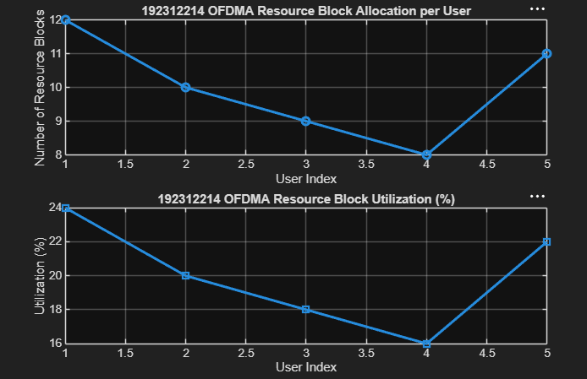

Objective 3 Matlab Code and Output
Program
clc; clear; close all;
% System parameters
rb_bw = 180e3; % Bandwidth per RB (180 kHz)
users = 1:5;
alloc_RB = [12 10 9 8 11];
mod_eff = [2 4 6 4 2]; % QPSK, 16QAM, 64QAM etc.
throughput = (alloc_RB .* rb_bw .* mod_eff) / 1e6;
disp('User Throughput (Mbps):')
disp(throughput')
figure
subplot(2,1,1)
title('192312214 OFDMA User Throughput')
xlabel('User Index')
ylabel('Throughput (Mbps)')
grid on
subplot(2,1,2)
plot(alloc_RB, throughput, '-s', 'LineWidth', 2)
title('192312214 Resource Blocks vs Throughput Relationship')
xlabel('Allocated Resource Blocks')
ylabel('Throughput (Mbps)')
grid on
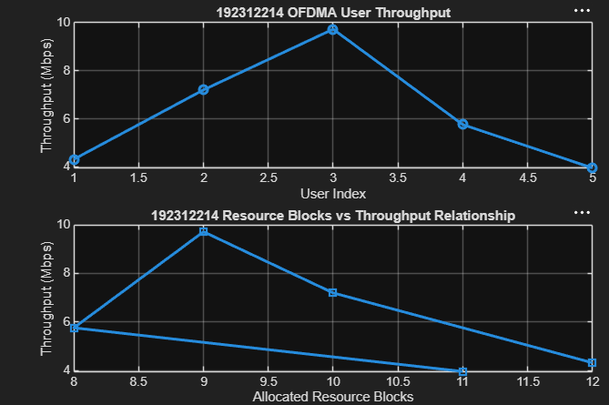
EXP 5: MIMO System Simulation with BER Analysis
Objective 1 Matlab Code and Output
Program
clc; clear; close all;
% SNR range
SNR_dB = 0:2:20;
SNR = 10.^(SNR_dB/10);
% MIMO parameters
Nt = 2; Nr = 2;
BER = zeros(1,length(SNR));
for i = 1:length(SNR)
bits = randi([0 1],10000,1);
symbols = 2*bits-1; % BPSK
noise = (randn(Nr,10000) + 1j*randn(Nr,10000))/sqrt(2*SNR(i));tx = H(1,1)*symbols' + noise(1,:);
rx = real(tx) > 0;
BER(i) = sum(rx' ~= bits)/length(bits);
end
figure
subplot(2,1,1)
semilogy(SNR_dB,BER,'-o','LineWidth',2)
title('192312214 MIMO BER Performance vs SNR')
xlabel('SNR (dB)')
ylabel('Bit Error Rate (BER)')
subplot(2,1,2)
plot(SNR_dB,1-BER,'-s','LineWidth',2)
title('192312214 MIMO System Reliability vs SNR')
xlabel('SNR (dB)')
ylabel('Reliability (1 - BER)')
grid on
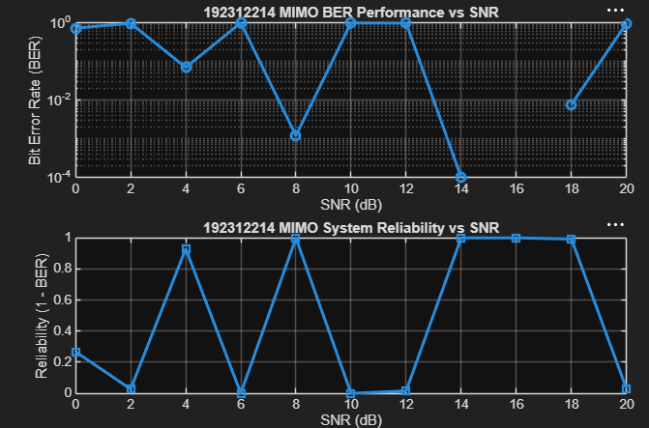

Objective 2 Matlab Code and Output
Program
clc; clear; close all;
% SNR range (dB)
SNR_dB = 0:2:20;
SNR = 10.^(SNR_dB/10);
% MIMO parameters
Nt = 2; Nr = 2;
% Simulated reliability metric (inverse BER model)
Reliability = zeros(1,length(SNR));
for i = 1:length(SNR)
% simple channel model effect
H = (randn(Nr,Nt) + 1j*randn(Nr,Nt))/sqrt(2);
noise_power = 1/SNR(i);
% reliability increases with SNR
Reliability(i) = 1 - exp(-SNR(i)/10);
end
figure
subplot(2,1,1)
plot(SNR_dB, Reliability, '-o', 'LineWidth', 2)
title('MIMO Reliability vs SNR')
xlabel('SNR (dB)')
ylabel('Reliability (0 to 1)')
grid on
subplot(2,1,2)
plot(SNR_dB, noise_power*ones(size(SNR_dB)), '-s', 'LineWidth', 2)
title('Noise Power Variation with SNR')
xlabel('SNR (dB)')
ylabel('Noise Power')
grid on
output
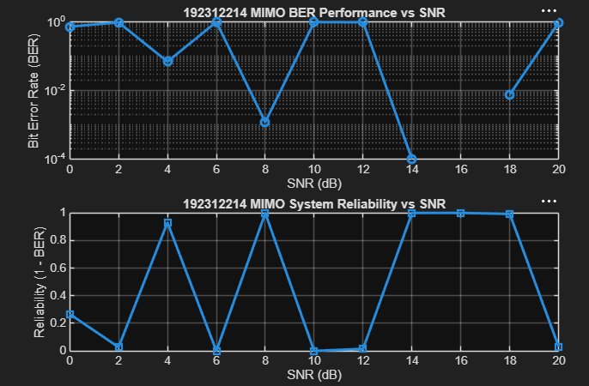
Objective 3 Matlab Code and Output:
Program
clc; clear; close all;
% Resource Block parameters
rb_bw = 180e3; % 180 kHz per RB
% Users
users = 1:5;
% Allocated Resource Blocks per user
alloc_RB = [10 12 8 15 5];
% Modulation efficiency (bits/symbol)
mod_eff = [2 4 6 4 2]; % QPSK, 16QAM, 64QAM etc.
% Throughput calculation (Mbps)
throughput = (alloc_RB .* rb_bw .* mod_eff) / 1e6;
% Display results
disp('User Throughput (Mbps):')
disp(throughput')
figure
% -------- Graph 1: Throughput per User --------
subplot(2,1,1)
plot(users, throughput, '-o','LineWidth',2)
title('192312214 OFDMA User Throughput')
xlabel('User Index')
ylabel('Throughput (Mbps)')
grid on
% -------- Graph 2: RB vs Throughput --------
subplot(2,1,2)
plot(alloc_RB, throughput, '-s','LineWidth',2)
title('192312214 Resource Blocks vs Throughput')
xlabel('Allocated Resource Blocks')
ylabel('Throughput (Mbps)')
grid on

output
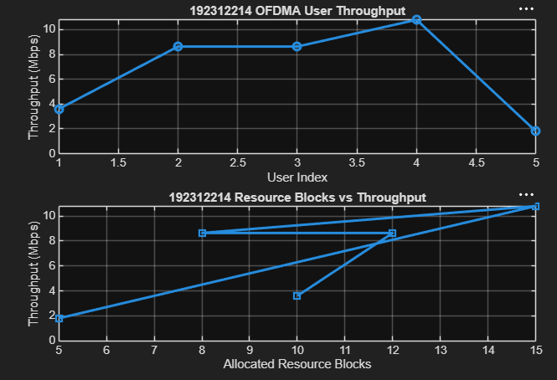

EXP: 6 5G NR Frame Structure Analysis with Different Subcarrier Spacing

Objective – 1: Analyze Different Subcarrier Spacing Values
Program code:
clc;
clear;
close all;
scs = [15 30 60 120 240]; % Subcarrier Spacing (kHz)
mu = 0:4; % Numerology Index
bar(scs)
grid on
set(gca,'XTick',1:5)
set(gca,'XTickLabel',mu)
xlabel('Numerology Index (\mu)')
ylabel('Subcarrier Spacing (kHz)')
title(' 192312214 5G NR Subcarrier Spacing for Different Numerologies')

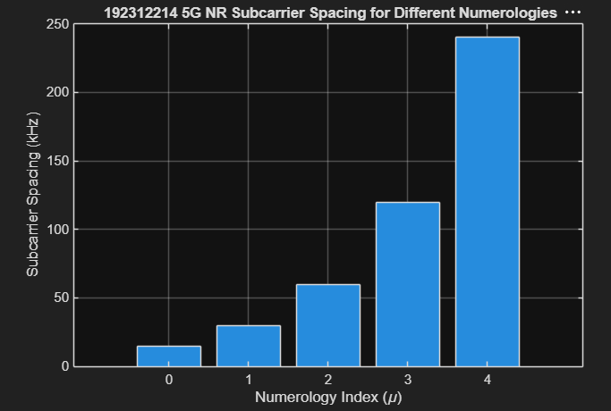
output:

Objective – 2 Compare Slot Duration
Program code:
clear;
close all;
scs = [15 30 60 120 240];
slot = [1 0.5 0.25 0.125 0.0625];
figure;
plot(scs, slot, 'o-', 'LineWidth', 2, 'MarkerFaceColor', 'b')
grid on
xlabel('Subcarrier Spacing (kHz)')
ylabel('Slot Duration (ms)')
title(' 192312214 5G NR Slot Duration for Different Subcarrier Spacing')
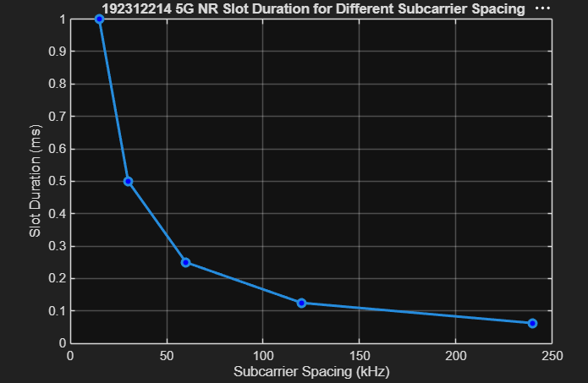

Objective – 3 Study the Number of OFDM Symbols

Program code:
clc;
clear;
close all;
scs = [15 30 60 120 240]; % Subcarrier Spacing (kHz)
symbols = [14 14 14 14 14]; % OFDM Symbols per Slot
figure
bar(scs, symbols)
grid on
xlabel('Subcarrier Spacing (kHz)')
ylabel('Number of OFDM Symbols')
title(' 192312214 OFDM Symbols per Slot for Different Subcarrier Spacing')
ylim([0 16])

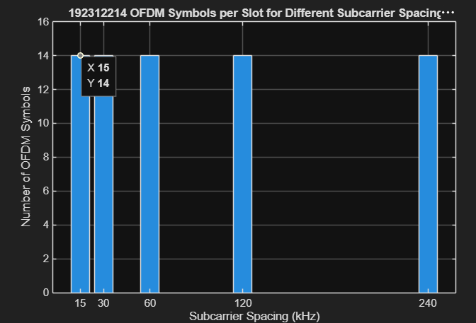
output:

EXP :7 Analog Beamforming Analysis Using MATLAB
Objective – 1: Analyze Beamforming Gain (dB)
Program code:
clc;
clear;
close all;
antennas = [2 4 8 16 32]; % Number of Antenna Elements
gain = 10*log10(antennas); % Beamforming Gain (dB)
figure
bar(antennas, gain)
grid on
xlabel('Number of Antenna Elements')
ylabel('Beamforming Gain (dB)')
title(' 192312214 Beamforming Gain for Different Antenna Array Sizes')
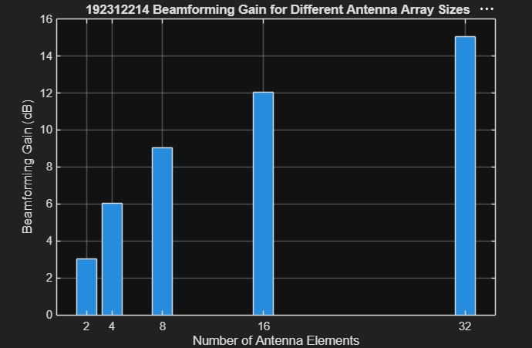
output:

Objective – 2: Compare Beam Width (Degrees)
Program code:
clc;
clear;
close all;
antennas = [2 4 8 16 32]; % Number of Antenna Elements
beamwidth = [90 45 22.5 11.25 5.625]; % Beam Width (degrees)
figure
plot(antennas, beamwidth,'o-','LineWidth',2)
grid on
xlabel('Number of Antenna Elements')
ylabel('Beam Width (Degrees)')
title(' 192312214 Beam Width for Different Antenna Array Sizes')
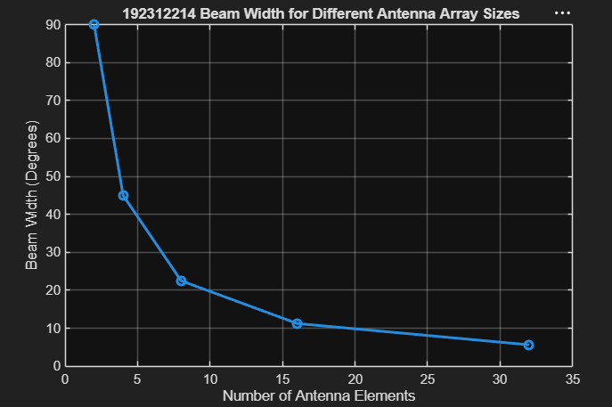

Objective – 3: Analyze Main Lobe Direction (Degrees)
program code:
clc;
clear;
close all;
theta = [-60 -30 0 30 60]; % Main Lobe Direction (degrees)
gain = [1 1 1 1 1]; % Constant normalized gain
figure
polarplot(deg2rad(theta), gain, 'o', 'LineWidth', 2)
title(' 192312214 Main Lobe Direction in Analog Beamforming')
output:
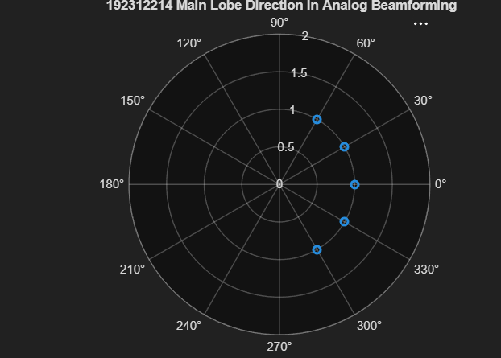

EXP 8: Steering Angle Variation in MIMO Beamforming Using MATLAB
Objective – 1 Analyze Steering Angle (Degrees)
Program code:
clc;
clear;
close all;
angle = [-60 -30 0 30 60]; % Steering Angles (degrees)
gain = ones(size(angle)); % Normalized Gain
figure
polarplot(deg2rad(angle), gain,'o-','LineWidth',2)
title(' 192312214 Steering Angle Variation in MIMO Beamforming')

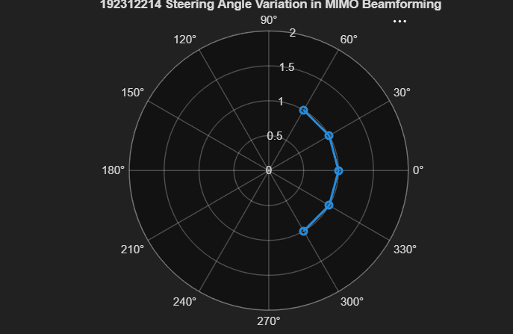
Objective – 2 Compare Array Gain (dB)
Program code:
clc;
clear;
close all;
angle = [-60 -30 0 30 60]; % Steering Angles (degrees)
gain = [9 12 15 12 9]; % Array Gain (dB)
figure
bar(angle, gain)
grid on
xlabel('Steering Angle (Degrees)')
ylabel('Array Gain (dB)')
title(' 192312214 Array Gain for Different Steering Angles')
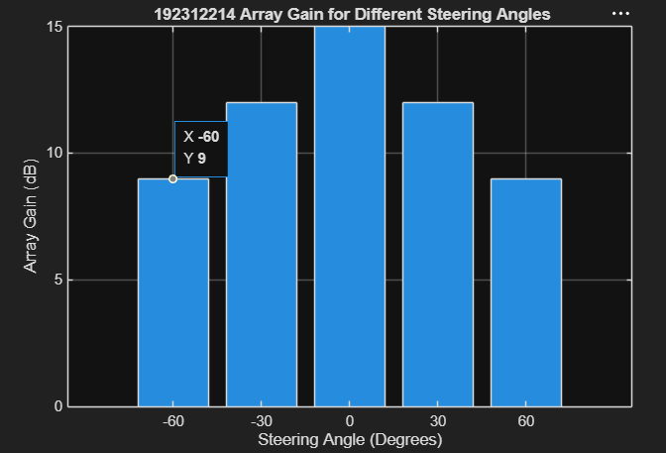
output :

Objective – 3 Evaluate Beam Direction Error (Degrees)
Program code:

clc;
clear;
close all;
desired = [-60 -30 0 30 60];
actual = [-58 -32 1 29 62];
error = abs(desired - actual);
figure
plot(desired, error, 'o-', 'LineWidth', 2)
grid on
xlabel('Desired Steering Angle (Degrees)')
ylabel('Beam Direction Error (Degrees)')
title(' 192312214 Beam Direction Error for Different Steering Angles')
output :
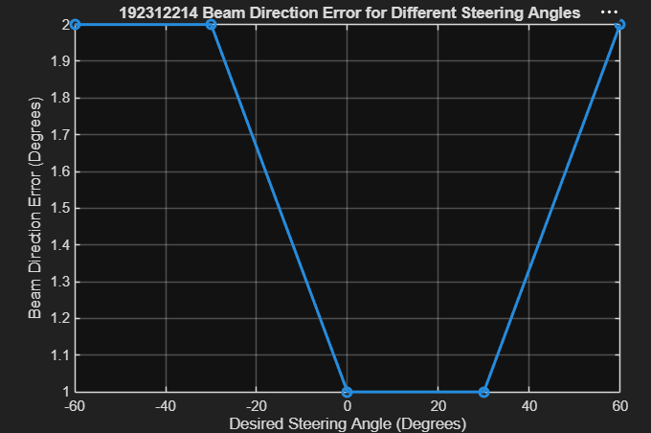

EXP 9: Massive MIMO Capacity vs SNR and Gain Using MATLAB
Objective – 1 Plot of Channel Capacity (bps/Hz) versus SNR(dB).
Program code:
clc;
clear;
close all;
snr = 0:5:30;
snr_linear = 10.^(snr/10);
capacity = log2(1 + snr_linear);
figure;
plot(snr,capacity,'-o','LineWidth',2,'MarkerSize',6);
grid on;
xlabel('SNR (dB)');
ylabel('Channel Capacity (bps/Hz)');
title(' 192312214 Channel Capacity vs SNR');
output
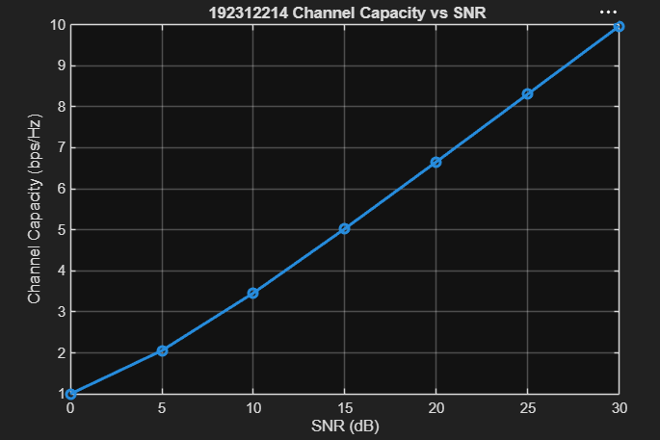

Objective – 2 Bar graph comparing SNR values under different communication scenarios.
Program code:
clc;
clear;
close all;
snr = 0:5:30;
snr_linear = 10.^(snr/10);
capacity = log2(1 + snr_linear);
plot(snr,capacity,'-o','LineWidth',2,'MarkerSize',6);
grid on;
xlabel('SNR (dB)');
ylabel('Channel Capacity (bps/Hz)');
title(' 192312214 Channel Capacity vs SNR');
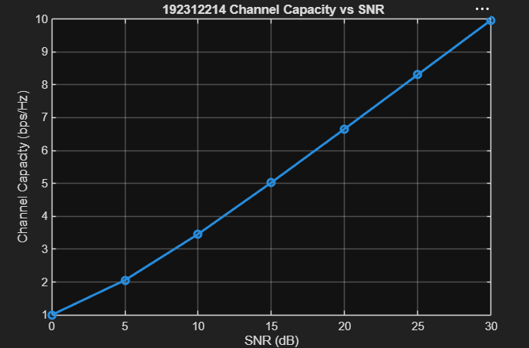
Objective – 3 Bar graph showing Antenna Gain for different antenna array sizes.
Program code:
clc;
clear;
close all;
antennas = [4 8 16 32 64];
gain = 10*log10(antennas);
figure
bar(antennas, gain)
grid on
xlabel('Number of Antenna Elements')
ylabel('Antenna Gain (dB)')
title(' 192312214 Antenna Gain for Different Antenna Array Sizes')

output
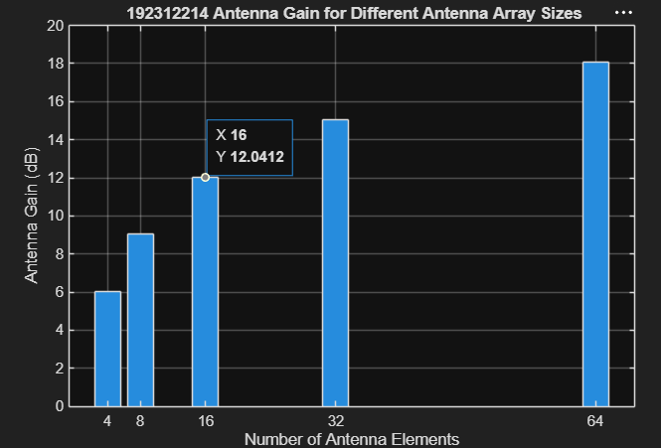
EXP 10: 5G Network Slicing Environment Using MATLAB
Objective – 1: Analyze the Number of Network Slices
Program code:
clc;
clear;
close all;
slices = {'eMBB','URLLC','mMTC','Private','IoT'};
count = [1 1 1 1 1]; % One instance of each network slice
figure
bar(count)
grid on
set(gca,'XTickLabel',slices)
xlabel('Network Slice Type')
ylabel('Number of Network Slices')
title('192312214 Number of Configured 5G Network Slices')
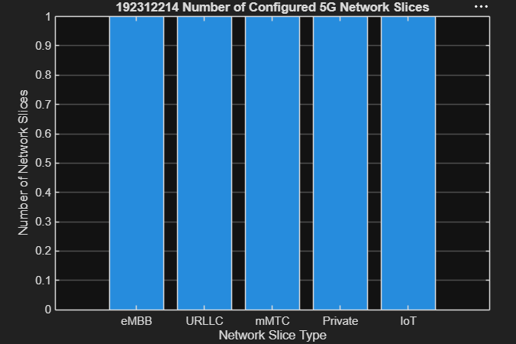
Objective – 2: Compare Slice Utilization (%)
Program code:
clc;
clear;
close all;
slices = categorical({'eMBB','URLLC','mMTC','Private','IoT'});utilization = [85 70 60 75 50];
figure;
bar(slices, utilization);
grid on;
xlabel('Network Slice Type');
ylabel('Slice Utilization (%)');
title(' 192312214 Slice Utilization in 5G Network Slicing');
output
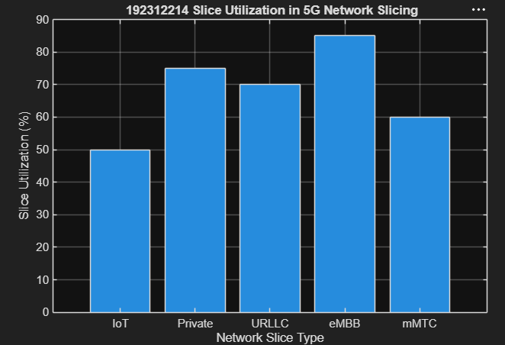
Objective – 3: Analyze End-to-End Latency (ms)
Program code:
clc;
clear;
close all;
slices = [1 2 3 4 5];
latency = [25 5 40 15 60];
figure;
plot(slices, latency, '-o','LineWidth',2,'MarkerSize',8);
grid on;
xticks(slices);
xticklabels({'eMBB','URLLC','mMTC','Private','IoT'});
xlabel('Network Slice Type');
ylabel('End-to-End Latency (ms)');
title(' 192312214 5G Network Slicing: End-to-End Latency');
ylim([0 70]);

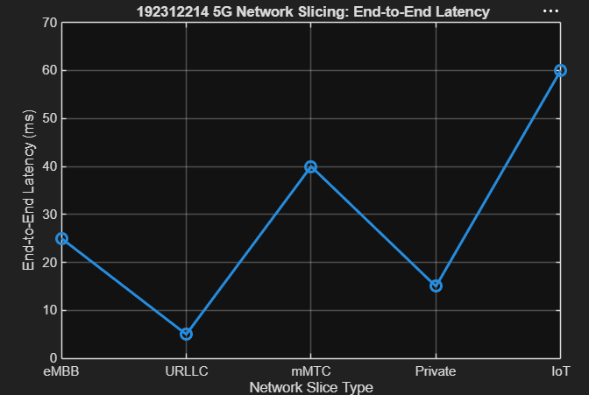
EXP 11: Implementation of IoT-based Smart Agriculture using MATLAB
Objective 1 Matlab Code and Output
Program code:
clc; clear; close all;
% Simulated soil moisture data (%)
time = 1:10;
soil_moisture = [30 35 28 25 20 18 22 30 40 45];threshold = 40;
figure subplot(2,1,1)
plot(time, soil_moisture, '-o', 'LineWidth', 2)
title(' 192312214 Soil Moisture Monitoring in IoT Smart Agriculture')
xlabel('Time (Hours)')
ylabel('Soil Moisture (%)')
grid on
hold on
yline(threshold,'r--','Threshold')
status = soil_moisture >= threshold;
subplot(2,1,2)
stem(time, status, 'filled', 'LineWidth', 2)
title('Soil Condition Status (1=Wet, 0=Dry)')
xlabel('Time (Hours)')
ylabel('Status')
grid on
output
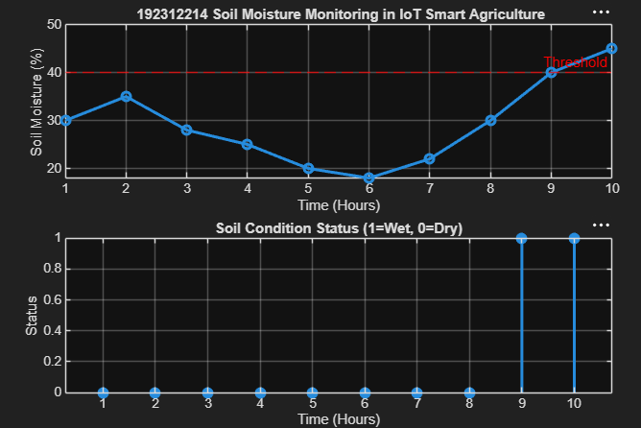

Objective 2 Matlab Code and Output
Program code:
clc; clear; close all;
% Simulated soil moisture (%)
time = 1:10;
soil_moisture = [30 35 28 25 20 18 22 30 40 45];
threshold = 40;
pump_status = soil_moisture < threshold;subplot(2,1,1)
plot(time, soil_moisture, '-o','LineWidth',2)
title('192312214 Soil Moisture vs Pump Control')
xlabel('Time (Hours)')
ylabel('Soil Moisture (%)')
grid onhold on
yline(threshold,'r--','Threshold')
subplot(2,1,2)
stem(time, pump_status, 'filled','LineWidth',2)
title('Water Pump Status (1=ON, 0=OFF)')
xlabel('Time (Hours)')
ylabel('Pump Status')
grid on
Output
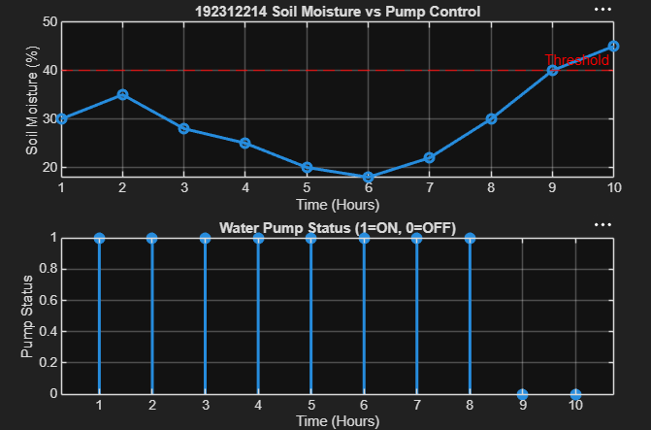

Objective 3 :Matlab Code and Output
Program code:
clc; clear; close all;
time = 1:10;
soil_moisture = [30 35 28 25 20 18 22 30 40 45];
threshold = 40;
efficiency = (soil_moisture ./ threshold) * 100;
efficiency(efficiency > 100) = 100; % limit to 100%figure
subplot(2,1,1)
plot(time, soil_moisture, '-o', 'LineWidth', 2)
title(' 192312214 Soil Moisture Variation')
xlabel('Time (Hours)')
ylabel('Soil Moisture (%)')
grid onhold on
yline(threshold, 'r--', 'Threshold')
subplot(2,1,2)
plot(time, efficiency, '-s', 'LineWidth', 2)
title(' 192312214 Irrigation Efficiency (%) in Smart Agriculture')
xlabel('Time (Hours)')
ylabel('Efficiency (%)')
grid on
Output
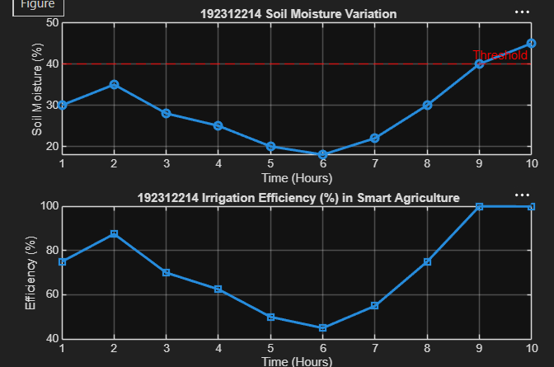
EXP 12: NB-IoT vs LTE-M Throughput Simulation Date
Objective 1 Matlab Code and Output
Program code:
clc; clear;close all;
SNR = 0:5:30;
% Simulated Throughput (Mbps)
NB_IoT = 0.05*(1-exp(-SNR/8));
LTE_M = 1.2*(1-exp(-SNR/8));
disp('SNR (dB) NB-IoT(Mbps) LTE-M(Mbps)')
disp([SNR' NB_IoT' LTE_M'])
subplot(2,1,1)
plot(SNR,NB_IoT,'-o','LineWidth',2)
title(' 192312214 NB-IoT Throughput vs SNR')
xlabel('Signal-to-Noise Ratio (dB)')
ylabel('Throughput (Mbps)')subplot(2,1,2)
plot(SNR,LTE_M,'-s','LineWidth',2)
title('LTE-M Throughput vs SNR')
xlabel('Signal-to-Noise Ratio (dB)')
ylabel('Throughput (Mbps)')
grid on
Output
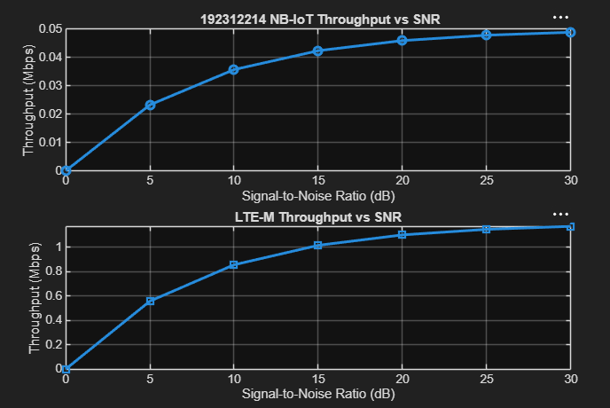

Objective 2 Matlab Code and Output
clc; clear; close all;
SNR = 0:5:30;
% Simulated Latency (ms)
NB_IoT = [180 160 145 130 120 110 100];
LTE_M = [90 80 70 60 50 45 40];
disp('SNR(dB) NB-IoT Latency(ms) LTE-M Latency(ms)')
disp([SNR' NB_IoT' LTE_M'])
subplot(2,1,1)
plot(SNR,NB_IoT,'-o','LineWidth',2)
title(' 192312214 NB-IoT Latency vs SNR')
xlabel('Signal-to-Noise Ratio (dB)')
ylabel('Latency (ms)')grid on
subplot(2,1,2)
plot(SNR,LTE_M,'-s','LineWidth',2)
title('LTE-M Latency vs SNR')
xlabel('Signal-to-Noise Ratio (dB)')
ylabel('Latency (ms)')
grid on
Output:
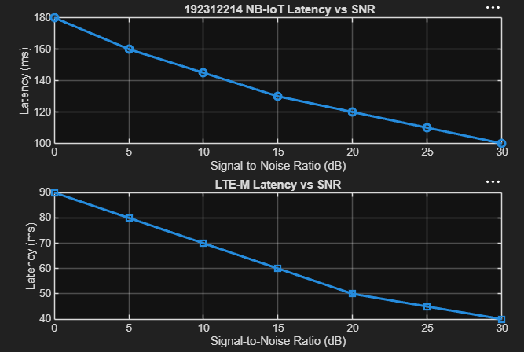
Objective 3 Matlab Code and Output:
Program code
clc; clear; close all;
SNR = 0:5:30;
NB_IoT = [82 86 89 92 95 97 99];
LTE_M = [88 91 94 96 98 99 100];
disp('SNR(dB) NB-IoT PDR(%) LTE-M PDR(%)')
disp([SNR' NB_IoT' LTE_M'])
subplot(2,1,1)
plot(SNR,NB_IoT,'-o','LineWidth',2)
title('192312214 NB-IoT Packet Delivery Ratio vs SNR')
xlabel('Signal-to-Noise Ratio (dB)')
ylabel('Packet Delivery Ratio (%)')
grid on
subplot(2,1,2)
plot(SNR,LTE_M,'-s','LineWidth',2)
title('LTE-M Packet Delivery Ratio vs SNR')
xlabel('Signal-to-Noise Ratio (dB)')
ylabel('Packet Delivery Ratio (%)')
grid on
Output:
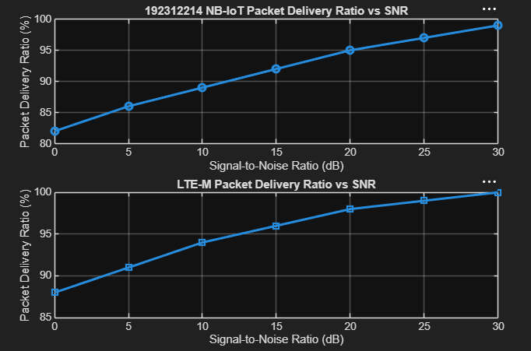
EXP 13: V2X Latency Comparison Date
Objective 1 Matlab Code and Output
clc;clear;close all;
% Vehicle Speed (km/h)
speed = 20:20:120;
% Simulated End-to-End Latency (ms)
latency = [18 16 14 12 10 9];
disp('Vehicle Speed (km/h) End-to-End Latency (ms)')
disp([speed' latency'])
subplot(2,1,1)
plot(speed,latency,'-o','LineWidth',2)
title('192312214 Vehicle Speed vs End-to-End Latency')
xlabel('Vehicle Speed (km/h)')
ylabel('Latency (ms)')
subplot(2,1,2)
plot(1:length(latency),latency,'-s','LineWidth',2)
title('Latency Variation Across Vehicles')
xlabel('Vehicle Index')
ylabel('End-to-End Latency (ms)')
grid on
Output:
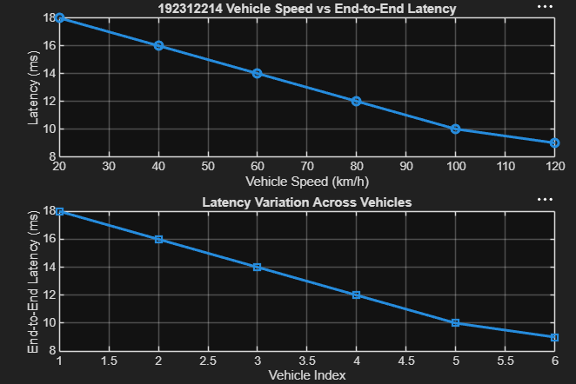

Objective 2 Matlab Code and Output:
Program code:
clc; clear; close all;
speed = 20:20:120;
% Simulated Packet Delivery Ratio (%)
PDR = [99 98 97 95 93 90];
disp('Vehicle Speed (km/h) Packet Delivery Ratio (%)')
disp([speed' PDR'])
subplot(2,1,1)
plot(speed,PDR,'-o','LineWidth',2)
title('192312214 Vehicle Speed vs Packet Delivery Ratio')
xlabel('Vehicle Speed (km/h)')
ylabel('Packet Delivery Ratio (%)')
subplot(2,1,2)
plot(1:length(PDR),PDR,'-s','LineWidth',2)
title('Packet Delivery Ratio Across Vehicles')
xlabel('Vehicle Index')
ylabel('Packet Delivery Ratio (%)')
grid on
Output :
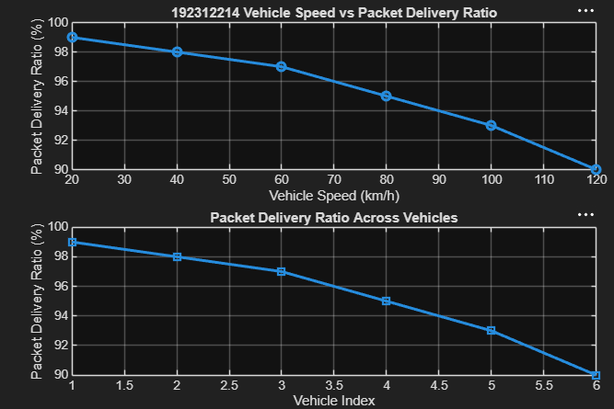
EXP 14: 5G Throughput vs SNR with Modulation Labels Date
Objective 1 Matlab Code and Output
Program code:
clc; clear; close all;
% Vehicle Speed (km/h)
speed = 20:20:120;
PDR = [99 98 97 95 93 90];
disp('Vehicle Speed (km/h) Packet Delivery Ratio (%)')
disp([speed' PDR'])
subplot(2,1,1)
plot(speed,PDR,'-o','LineWidth',2)
title('192312214 Vehicle Speed vs Packet Delivery Ratio')
xlabel('Vehicle Speed (km/h)')
ylabel('Packet Delivery Ratio (%)')subplot(2,1,2)
plot(1:length(PDR),PDR,'-s','LineWidth',2)
title('Packet Delivery Ratio Across Vehicles')
xlabel('Vehicle Index')
ylabel('Packet Delivery Ratio (%)')
grid on
Output
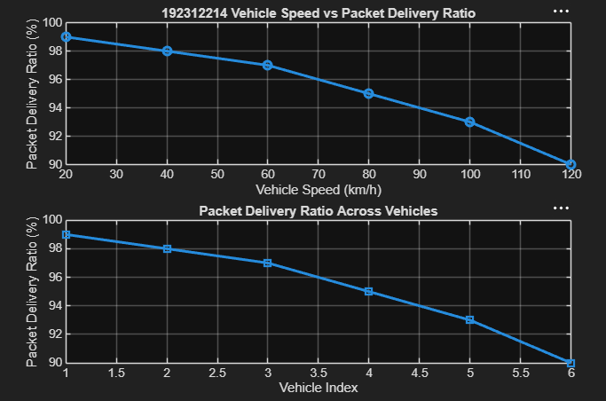

Objective 3 Matlab Code and Output
Program code:
clc; clear; close all;
Modulation = {'QPSK','16-QAM','64-QAM','256-QAM'};
SNR = [5 10 18 25];
Efficiency = [2 4 6 8];
disp('Required SNR (dB) and Spectral Efficiency')
disp(table(Modulation',SNR',Efficiency', ...
'VariableNames',{'Modulation','SNR_dB','Efficiency'}))
subplot(2,1,2)
plot(SNR,Efficiency,'-o','LineWidth',2)
title(' 192312214 SNR vs Spectral Efficiency')
xlabel('Signal-to-Noise Ratio (dB)')
ylabel('Spectral Efficiency (bits/s/Hz)')
subplot(2,1,1)
plot(1:4,SNR,'-s','LineWidth',2)xticklabels(Modulation)
title('Required SNR for Different Modulation Schemes')
xlabel('Modulation Scheme')
ylabel('Required SNR (dB)')
grid on
Output
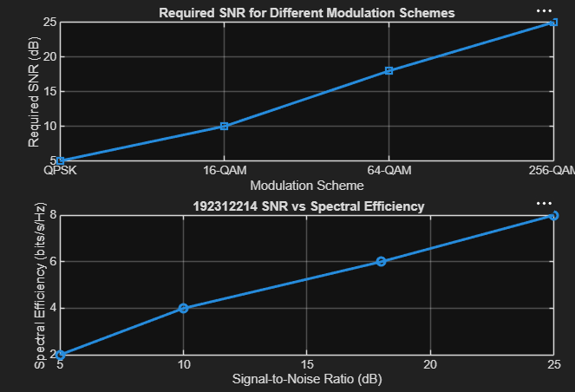
EXP 15: AI-based Traffic Prediction for 5GNetworks
Objective 1: To simulate 5G network traffic data and visualize the traffic pattern.
Program code:
clc; clear; close all;
time = 1:20;
traffic = [20 25 30 35 40 50 60 58 65 70 ...
75 80 78 85 90 95 100 98 105 110];
figure;
plot(time, traffic, '-o', 'LineWidth', 2); grid on;
xlabel('Time (Hours)');
ylabel('Network Traffic (Mbps)');
title(' 192312214 Simulated 5G Network Traffic');
Output:
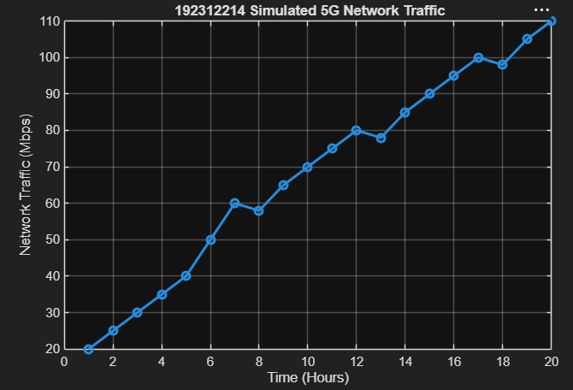
Objective 2: To predict future 5G network traffic using MachineLearning (Linear Regression).
Program code:
clc;
clear;
close all;
% Simulated Traffic Data
time = 1:20;
traffic = [20 25 30 35 40 50 60 58 65 70 ...
75 80 78 85 90 95 100 98 105 110];
% Linear Regression Model
model = polyfit(time, traffic, 1);
% Predicted Traffic
predicted = polyval(model, time);
figure;
plot(time, traffic, 'bo-', 'LineWidth', 2);
hold on;
plot(time, predicted, 'r*-', 'LineWidth', 2);
grid on;
xlabel('Time (Hours)');
ylabel('Network Traffic (Mbps)');
title(' 192312214 AI-Based Traffic Prediction using Linear Regression');legend('Actual Traffic', 'Predicted Traffic', 'Location', 'best');
Output:
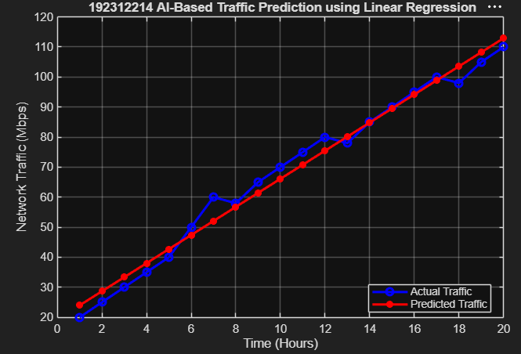

Objective 3: To evaluate the prediction accuracy by comparingactual and predicted traffic values.
Program code:
clc;
clear;
close all;
% Simulated Traffic Data
time = 1:20;
traffic = [20 25 30 35 40 50 60 58 65 70 ...
75 80 78 85 90 95 100 98 105 110];
model = polyfit(time, traffic, 1);
error = traffic - predicted;
RMSE = sqrt(mean(error.^2));
disp(['Root Mean Square Error (RMSE) = ', num2str(RMSE)]);
subplot(2,1,1);
plot(time, traffic, 'bo-', 'LineWidth', 2);
plot(time, predicted, 'r*-', 'LineWidth', 2); grid on;
xlabel('Time (Hours)');
ylabel('Traffic (Mbps)');
title(' 192312214 Actual vs Predicted Traffic');
legend('Actual', 'Predicted', 'Location', 'best');
subplot(2,1,2);
bar(time, error); grid on;
xlabel('Time (Hours)');
ylabel('Prediction Error (Mbps)');
title(' 192312214 Prediction Error');
disp('Time Actual Predicted');
disp([time' traffic' predicted']);
Output:
